This file contains the in-depth points and patterns observed while conducting EDA which motivated and guided the feature selection process for LIME.

1.Feature Redundancy and Correlation Structure
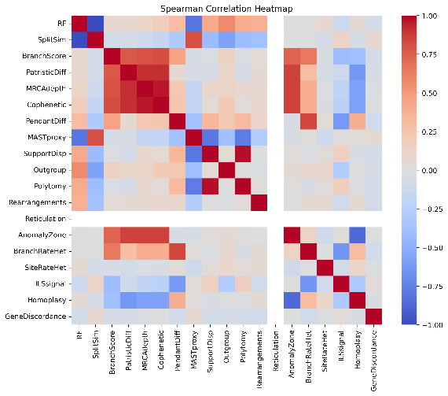
Pairwise correlations between all candidate features were examined using both Pearson and Spearman correlation coefficients. As visible in Figures 1 and 2, across both correlation measures, a strong block of positively correlated features is observed among several commonly used topological and ancestry-based distances. These include RF-style split differences, patristic distance variants, MRCA depth, and cophenetic distance. This indicates that these features encode overlapping structural information and are unlikely to contribute independently if combined directly. In contrast, rearrangement-sensitive proxies (MASTproxy) and branch-rate related features exhibit weaker correlations with RF and path-based distances. These capture aspects of tree dissimilarity that are not well explained by split-based topology alone.
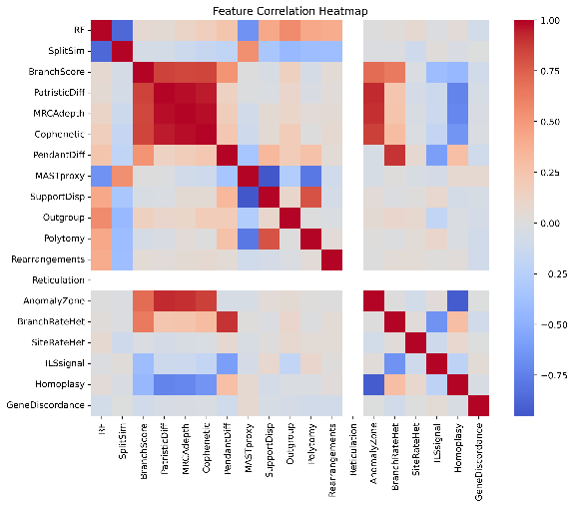

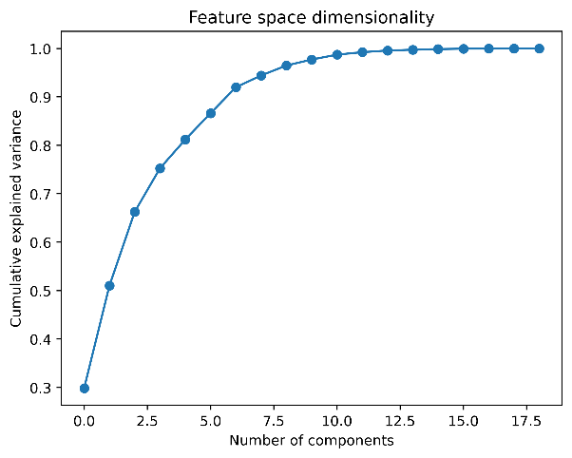
2. Low-Dimensional Structure of Feature Space
To assess whether the full feature set contains low dimensional structure, we analysed the cumulative explained variance of the normalized feature matrix using principal component analysis. Figure 3 plots the cumulative variance curve which shows that a large fraction of the total variance is explained by a relatively smaller number of components, with diminishing gains beyond the first few dimensions. This supports the conclusion that many features are redundant and . suggests that a compact feature set can preserve most of the meaningful variation present in the data

3. Stability and Saturation Behavior
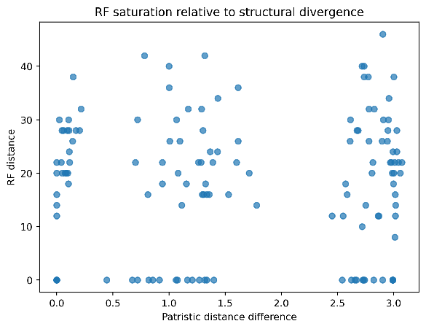

The behaviour of the Robinson Foulds (RF) distance under increasing structural divergence was then examined by comparing RF values against patristic distance differences (Figure 4). As patristic distance increases, RF values do not spread proportionally but instead collapse into discrete horizontal bands with substantial overlap. Tree pairs exhibiting quite different patristic distances are frequently assigned similar RF values.

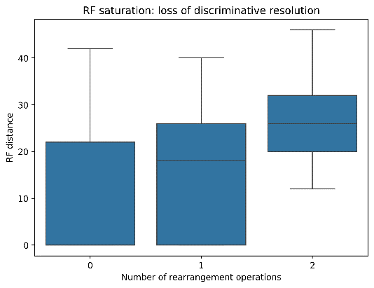
This behaviour reflects a loss of discriminative resolution, i.e. beyond moderate divergence, RF cannot reliably distinguish the magnitude of structural differences between trees. A complementary view is provided by the distribution of RF values grouped by the number of rearrangement operations (Figure 5). While median RF values increase, the overlap between distributions remains large, further indicating limited resolution at higher divergence levels.

4.Comparison with a Rearrangement-Sensitive Metric
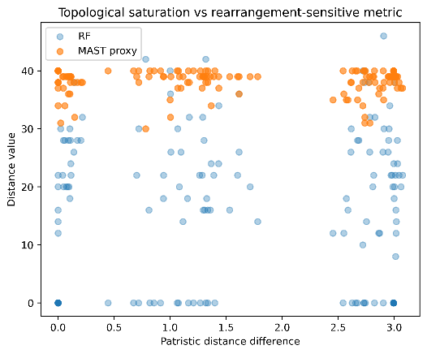
To contrast RF with a rearrangement-aware alternative, RF distances were compared directly with a rearrangement-sensitive proxy (MASTproxy) as a function of patristic distance (Figure 6). As noted in the last point, as patristic distance increases, RF values cluster into discrete, overlapping bands indicating a loss of resolution. In contrast, the rearrangement-sensitive proxy remains bounded away from zero and is more or less independent from purely branch-length driven divergence. This divergence in behaviour highlights the need of inclusion of rearrangement-aware components in LIME to retain sensitivity across complementary evolutionary dimensions.

These observations directly informed the selection of features used to construct the final LIME metric, described in the following section.
- To reduce redundancy, representative features were retained while highly correlated alternatives were excluded.
- Analysis of feature behaviour under increasing divergence further informed selection. As RF-style distances were observed to lose discriminative resolution, the role of split-based topology was reduced and features that preserve resolution at higher divergence levels were taken with it.
- Features belonging to Category B and Category C were used exclusively to interpret feature behaviour during analysis and were not included in the final metric, as they rely on simulation parameters or known perturbations unavailable in real-world comparisons. Consequently, the final feature set consists entirely of Category A features that are directly computable from pairs of phylogenetic trees.

